Install MiniKube on Ubuntu

1. sudo apt update -y
2. sudo apt install -y curl wget apt-transport-https

Download the Minikube binary

1. curl -LO <https://storage.googleapis.com/minikube/releases/latest/minikube-linux-amd64>

Install the downloaded MiniKube

1. sudo install minikube-linux-amd64 /usr/local/bin/minikube

Verify Minikube installation.

1. minikube version

Download Kubectl binary.

1. curl -LO https://storage.googleapis.com/kubernetes-release/release/$(curl -s <https://storage.googleapis.com/kubernetes-release/release/stable.txt)/bin/linux/amd64/kubectl>
2. chmod +x kubectl
3. Sudo mv kubectl /usr/local/bin

Verify Kubectl version.

1. kubectl version -o yaml

Give user permission to run docker commands.

1. usermod -G docker $(whoami)

Logout from ubuntu and login again. This will apply the user group membership.

Now start the Minikube.

1. minikube start — driver=docker

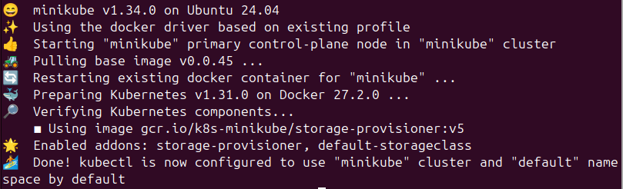

You should get an output as shown above.

Verify using following command.

1. minikube status

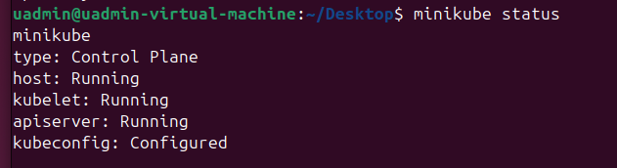

Important Kubernetes commands

1. kubectl cluster-info

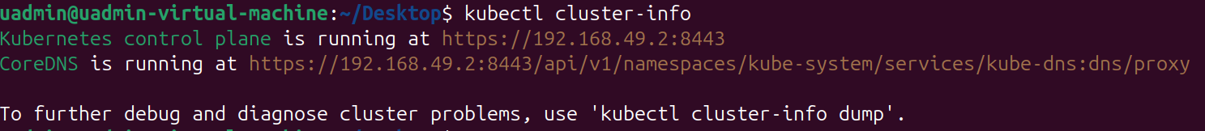

1. kubectl get nodes

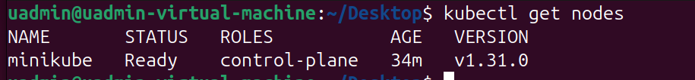

1. kubectl get pods --all-namespaces

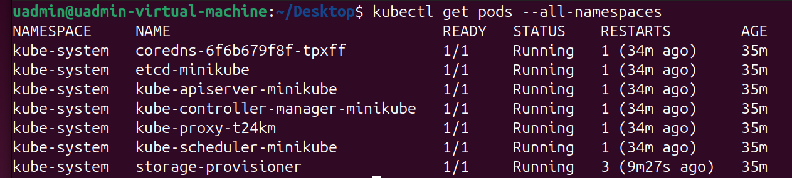

1. kubectl get deployment



1. kubectl get services

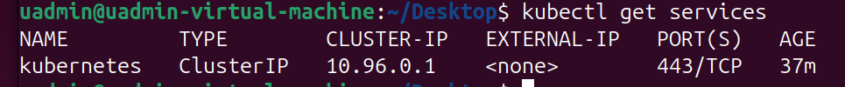

1. minikube stop

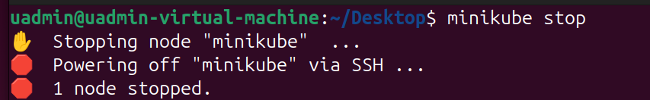

Make sure before you shut down the computer, you shut down the Minikube using above command.

Minikube Dashboard

1. Start minikube dashboard.

minikube dashboard

1. Enable ingress controller.

minikube addons enable ingress

1. To get dashboard URL

minikube dashboard --url